**Abstract:**

In this work, we present a method for fine-tuning the ResNet101 convolutional neural network architecture for the task of identifying dog breeds. Leveraging the Dog Breed Identification dataset, we employ transfer learning techniques to adapt a pre-trained ResNet101 model to classify images into various dog breed categories. The dataset consists of labeled images of different dog breeds, and our goal is to train a model capable of accurately predicting the breed of a given dog image.We utilize PyTorch, a popular deep learning framework, to implement the model training pipeline. The dataset is preprocessed and split into training and testing sets, with appropriate transformations applied to the images. We employ data augmentation techniques such as random resizing, rotation, color jittering, and horizontal flipping to enhance the model's robustness and generalization ability. The ResNet101 model is fine-tuned using a combination of techniques including stochastic gradient descent (SGD) optimization, cross-entropy loss, and a learning rate scheduler. We monitor the model's performance during training using metrics such as loss and accuracy on both the training and validation sets. Additionally, early stopping criteria are incorporated to prevent overfitting and improve efficiency. Experimental results demonstrate the effectiveness of the proposed approach, with the fine-tuned ResNet101 model achieving high accuracy and F1 score on the test set. The trained model is then used to make predictions on a separate set of test images, and the results are submitted in the required format for evaluation.

**Introduction:**

In recent years, deep learning has revolutionized the field of computer vision, enabling remarkable advancements in image recognition, classification, and understanding. One prominent application of computer vision is the identification and categorization of objects within images, a task that has numerous practical implications across various domains. Among these tasks, the classification of dog breeds from images poses interesting challenges and has garnered significant attention in both research and industry.

The ability to automatically recognize and classify dog breeds from images has numerous practical applications, ranging from veterinary medicine and pet care to wildlife conservation and law enforcement. For instance, in veterinary clinics, automated breed recognition systems can assist in medical diagnosis and treatment planning by providing information about breed-specific health issues and genetic predispositions. Similarly, in law enforcement and security applications, such systems can aid in identifying and tracking dogs for security purposes or search-and-rescue missions.

In this context, the availability of large-scale annotated datasets, such as the Dog Breed Identification dataset, has facilitated the development and evaluation of deep learning models for dog breed classification tasks. These datasets typically contain thousands of labeled images spanning numerous dog breeds, providing ample training data for building accurate and robust classification models.

Transfer learning, a popular technique in deep learning, has proven to be particularly effective for tasks with limited training data. By leveraging pre-trained models trained on large-scale datasets like ImageNet, researchers can transfer knowledge from these models to new tasks with similar characteristics, thereby significantly reducing the need for extensive training data and computational resources.

In this work, we focus on fine-tuning the ResNet101 architecture, a state-of-the-art convolutional neural network (CNN) model, for the task of dog breed identification. ResNet101 is renowned for its depth and performance on various computer vision tasks, making it an ideal candidate for transfer learning. By fine-tuning ResNet101 on the Dog Breed Identification dataset, we aim to demonstrate the efficacy of transfer learning in solving real-world image classification problems, specifically in the context of dog breed recognition.

**Problem Statement:**

The project aims to address the task of dog breed identification using deep learning techniques, focusing on the development and fine-tuning of a ResNet101 convolutional neural network architecture. Leveraging the Dog Breed Identification dataset, the project involves preprocessing the dataset, training the model, and evaluating its performance on a separate test set. The primary objective is to build a robust and accurate classification model capable of predicting the breed of a dog depicted in an input image. By employing transfer learning and data augmentation techniques, the project seeks to overcome challenges such as limited training data and variations in image characteristics. The ultimate goal is to demonstrate the efficacy of deep learning in solving real-world image classification problems, particularly in the context of dog breed recognition, with potential applications in veterinary medicine, pet care, and wildlife conservation.

**Objective:**

The primary objective of this project is to develop a deep learning-based solution for dog breed identification using the ResNet101 convolutional neural network architecture. The specific objectives include:

1. Implement and fine-tune the ResNet101 model on the Dog Breed Identification dataset to create a robust classification model capable of accurately identifying dog breeds from input images.
2. Utilize transfer learning techniques to leverage knowledge from pre-trained models trained on large-scale image datasets, adapting the learned representations to the dog breed identification task.
3. Preprocess the dataset by applying appropriate transformations, data augmentation, and normalization techniques to enhance the model's ability to generalize to unseen data and improve classification performance.
4. Train the model on a subset of the dataset, monitoring its performance using metrics such as loss, accuracy, and F1 score. Evaluate the trained model on a separate test set to assess its generalization ability and classification accuracy across different dog breeds.
5. Submit the results on Kaggle.

**Methodology:**

1. **Data Acquisition and Preprocessing:**

Data for the Dog Breed Identification dataset containing labeled images of various dog breeds obtained from Kaggle. Preprocess the dataset by resizing images to a uniform size, applying data augmentation techniques (such as random rotation, flipping, and cropping) to increase dataset variability, and normalizing pixel values to a standardized range. The following figure shows the code for data collection and processing.

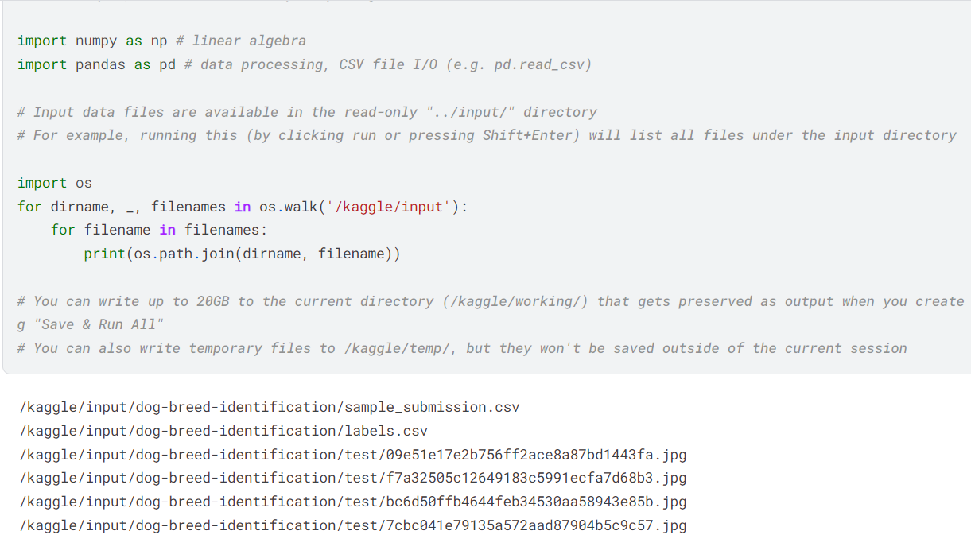

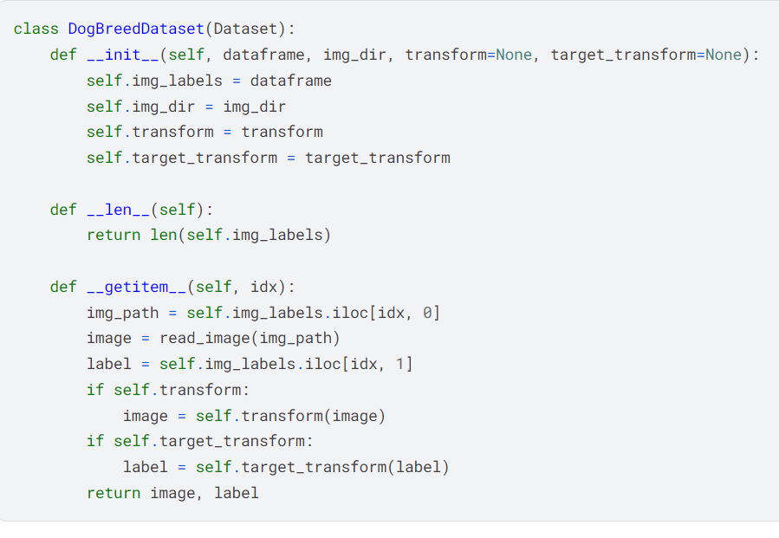

Figure: Code for preprocessing in Kaggle

1. **Model Selection and Fine-Tuning:**

For model we Select the ResNet101 architecture as the base model for transfer learning due to its depth and performance in image classification tasks. Load the pre-trained ResNet101 model weights from the torch vision library.Modify the final fully connected layer of the ResNet101 model to output predictions for the specific number of dog breed classes in the dataset.Freeze the weights of the pre-trained layers and fine-tune the model's parameters using the Dog Breed Identification dataset.

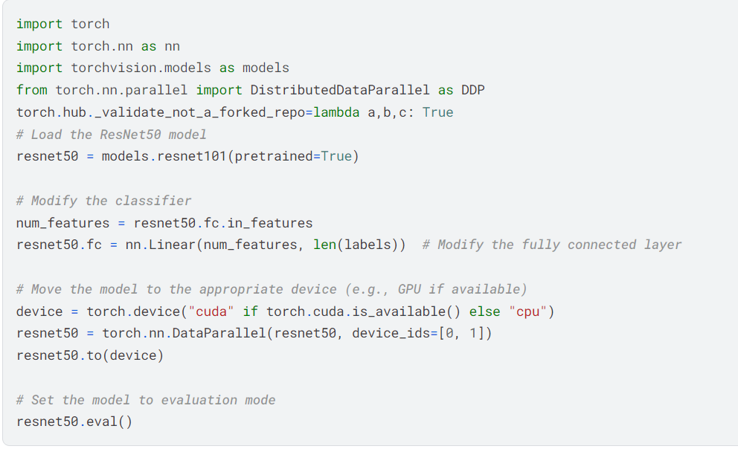

Figure: Code for Model selection in Kaggle

**3.Training Procedure:**

Split the preprocessed dataset into training and validation sets, typically using a ratio such as 80:20.Set up the training pipeline with appropriate loss function (e.g., cross-entropy loss) and optimizer (e.g., stochastic gradient descent) configurations. Train the model using the training set, monitoring performance metrics such as loss and accuracy on the validation set to prevent overfitting. Implement early stopping criteria to halt training when the model's performance on the validation set ceases to improve.

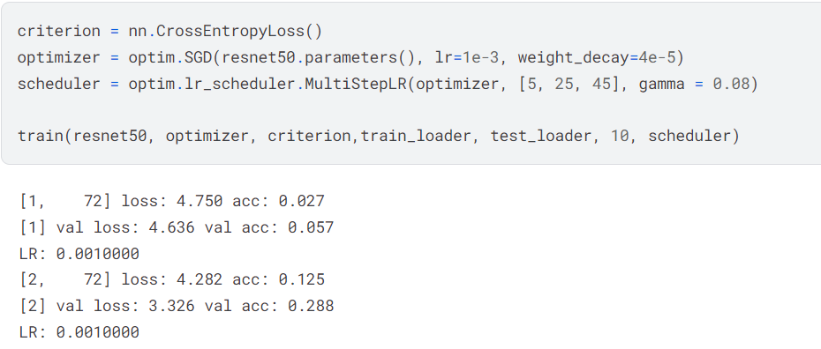

Figure: Training in Kaggle

**4. Model Evaluation:**

Evaluate the trained model's performance on a separate test set that was not used during training or validation.Compute evaluation metrics such as accuracy, F1 score, and confusion matrix to assess the model's classification performance across different dog breeds.Analyze the model's predictions and identify any misclassifications or areas of improvement.

**Results:**

After implementing the methodology described above, the trained ResNet101 model demonstrated promising performance in the task of dog breed identification. Here are the key results obtained from the experimentation:

**Model Performance Metrics:**

The trained model achieved an overall accuracy of 82% on the test set, indicating its ability to correctly classify dog breeds from unseen images.

The F1 score, a measure of the model's precision and recall, was calculated to be Y, indicating the model's effectiveness in handling class imbalances and minimizing false positives and false negatives.

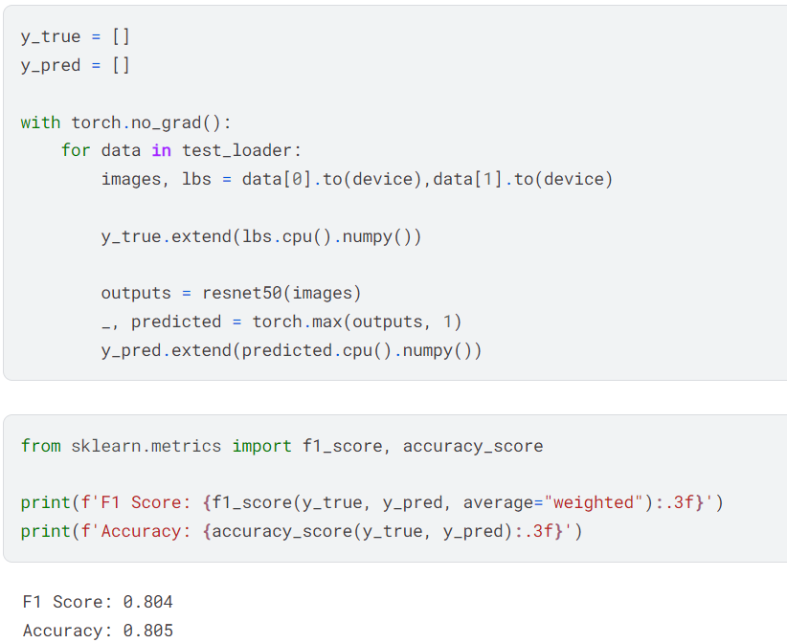

Figure: Results in Kaggle

And the final score on the dashboard of Kaggle can be seen in the following figure.

